Assignment 2

Name: Adarsh Shah

Dept: MTech (AI)

Sr No: 19473

**This project uses scipy.optimize and scipy.signals libraries additionally.**

# Contrast Enhancement

## Full Scale Contrast Enhancement

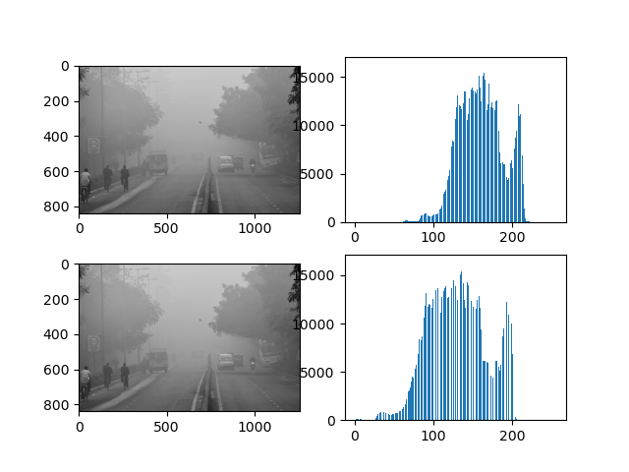

There is not much change in the result image as the original one is already utilizing most of the spectrum.

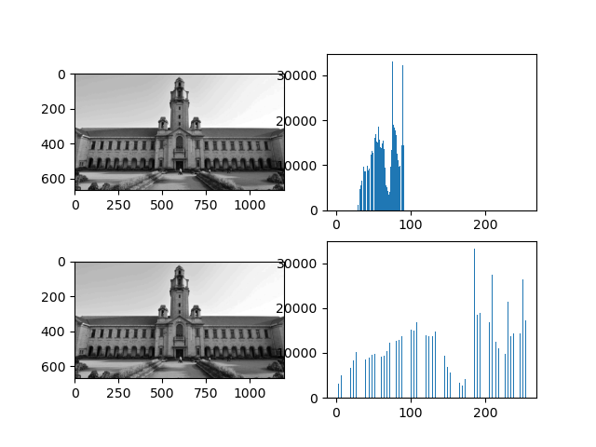

The FSCS shows better result for this image and the resultant image is brighter than before as the dynamic range increases.

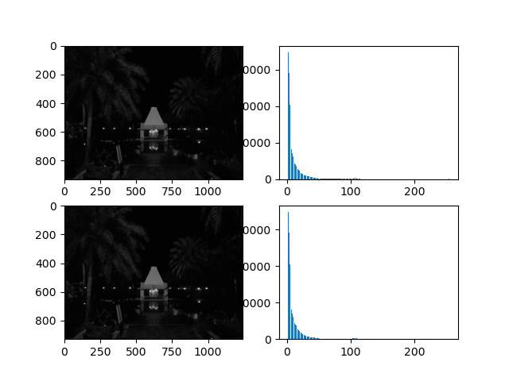

There is not much change in the result image as the original one is already utilizing most of the spectrum.

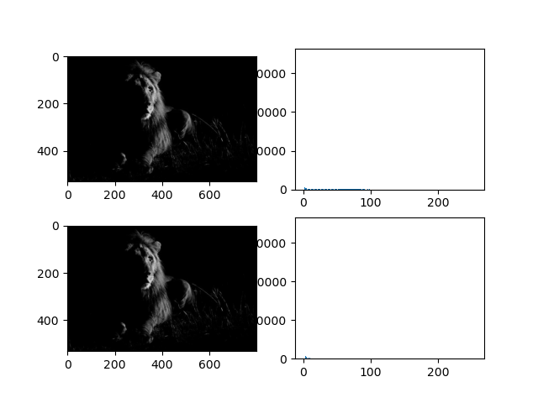

There is not much change in the result image as the original one is already utilizing most of the spectrum.

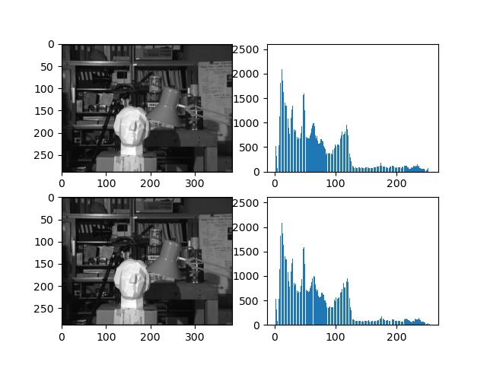

There is not much change in the original image as the original one is already utilizing most of the spectrum.

## Nonlinear Contrast Stretching (Logarithmic)

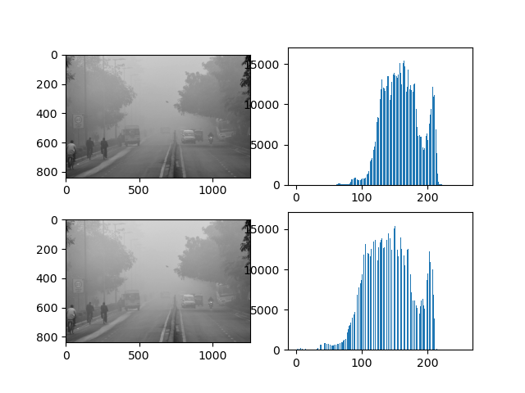

There is not much effect of non-linear contrast stretch because most of the pixel intensities are concentrated in the brighter range.

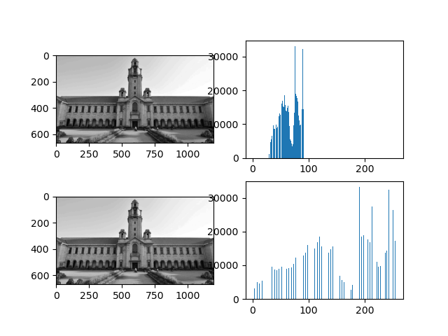

The pixel intensities in the lower range are more spread out in logarithmic non line contrast stretch. This results in image with larger dynamic range.

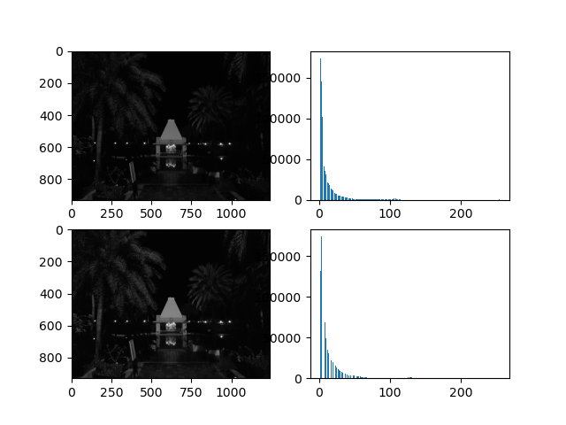

Some fine details in the image become clearer as the dynamic range increases and the fine details are brighter as compared to their surroundings.

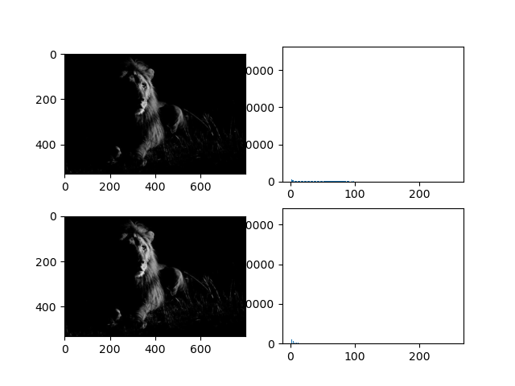

There is not much difference as most of the pixel intensities are concentrated to dark narrow range.

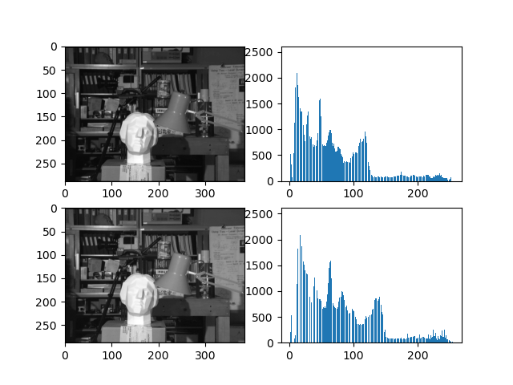

There is not much difference and only some details are clearer.

## Histogram Equalization

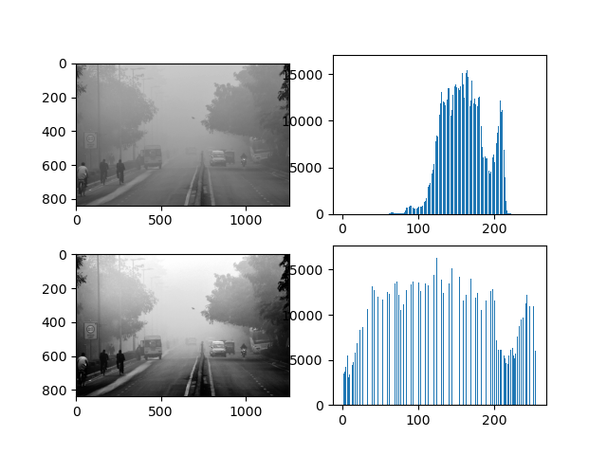

The image is less foggy than before because the histogram equalization spreads out the pixel intensities.

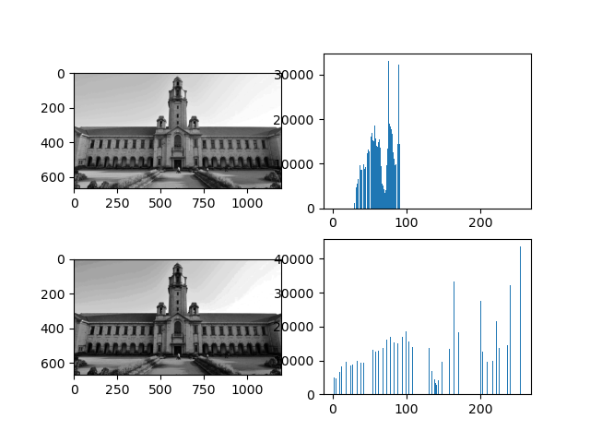

The image has better dynamic range than before because the algorithm spreads out the pixel intensities.

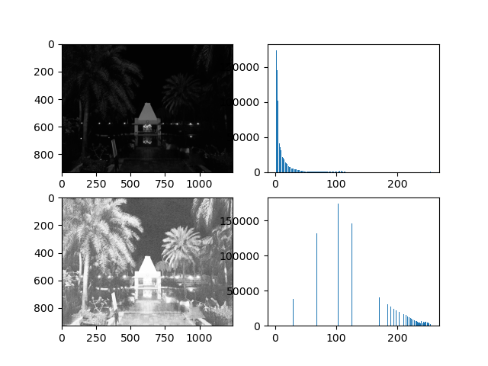

The image is brighter than before as the dynamic range is increased. However, there are multiple bright objects in picture with smaller distributed intensity so it becomes difficult to notice the finer details as all the smaller distributed intensities are brightened.

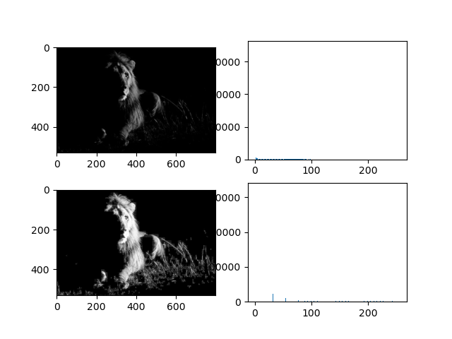

This algorithm worked best for this image because there is a brighter object with varied intensities on a dark background.

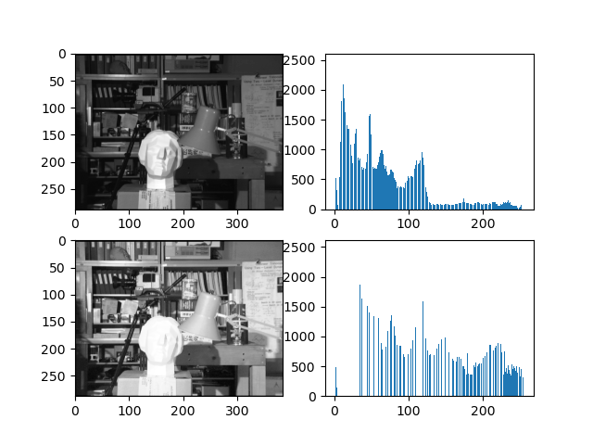

The face of the statue becomes more invisible because the average intensity of face is more compared to the background and the variance is less.

## CLAHE

The boundary artifacts present in the result image is a major disadvantage of CLAHE.

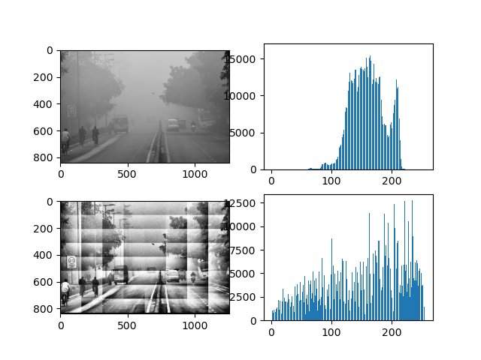

The image is less foggier than before because the intensities in each grid have less variance and are spread out by the algorithm.

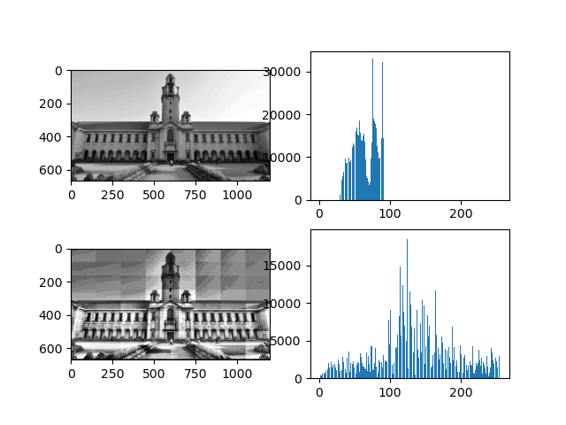

The image’s dynamic range is increased because the intensities in each grid have less variance and are spread out by the algorithm. Some finer details get highlighted.

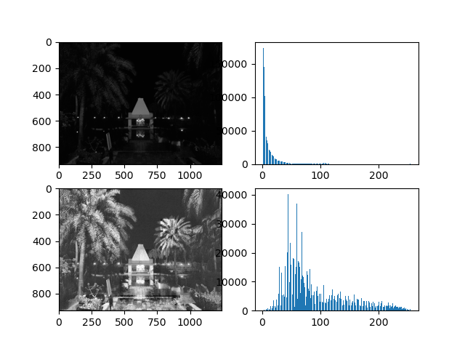

This algorithm worked best for this image because the objects almost occupy the grid and intensity of the details in them are spread out by the algorithm.

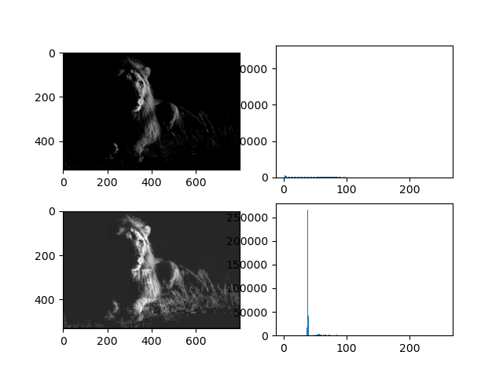

The same reason as previous.

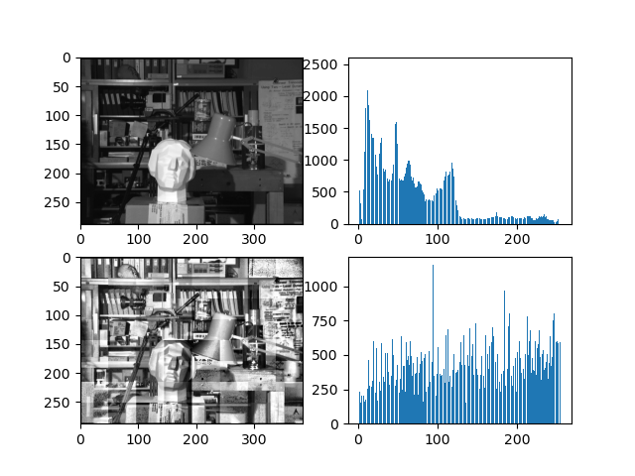

The face is more clearly visible due to the previous reason.

## CLAHE with 25% more boundaries

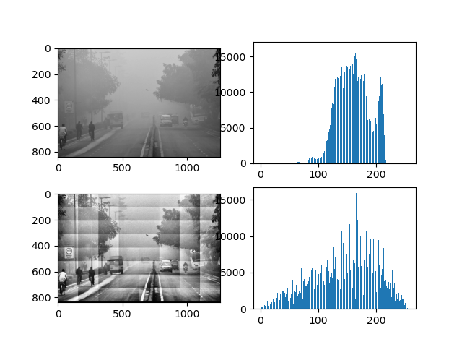

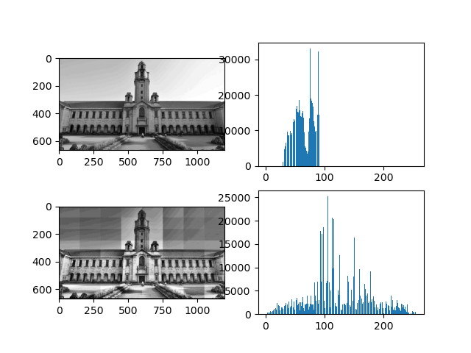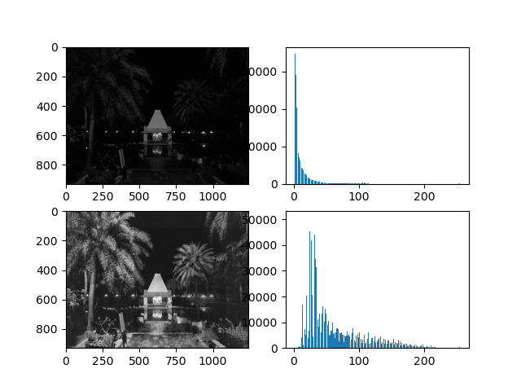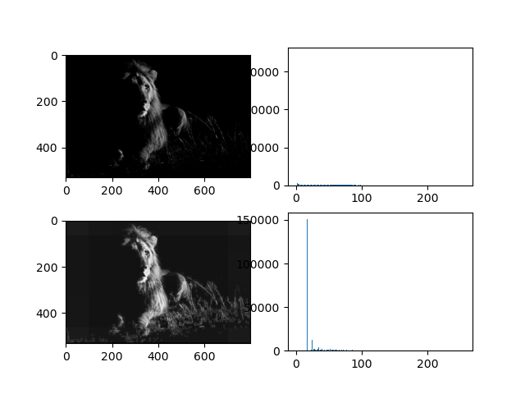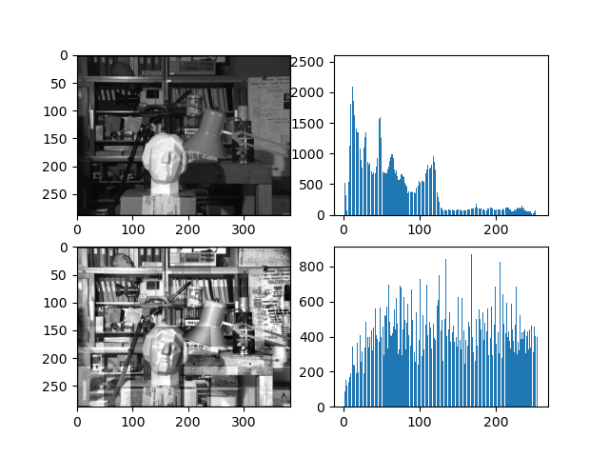

The main difference between CLAHE and CLAHE1 is the reduction in the boundary artifacts. This is because by taking information from the neighbouring grids into account, the difference in the average intensities between the grid reduces.

# Interpolation

The left image is smooth one and the right image is the upsampled.

## Nearest Neighbour Interpolation

## Bilinear Interpolation

It is evident from mean square error that bilinear interpolation gives better result than nearest neighbour.

# Rotation

# High Boost Filtering

The smooth image is given as input to high-boost filtering.

Here, Optimal k after minimization is specified in the image. It can be observed that as k increases, mean squared error increases too. The “m” specifies the averaging window used.

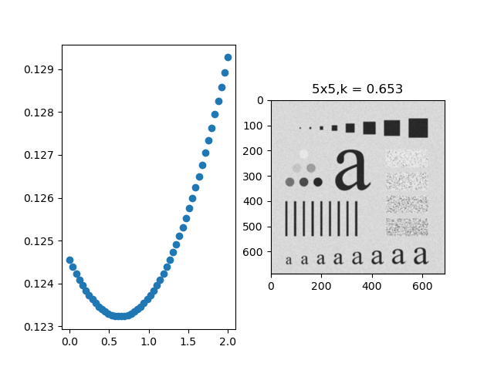

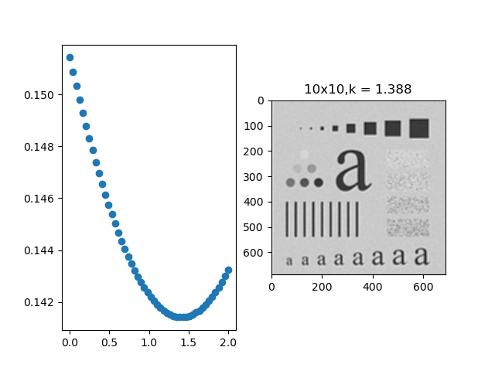

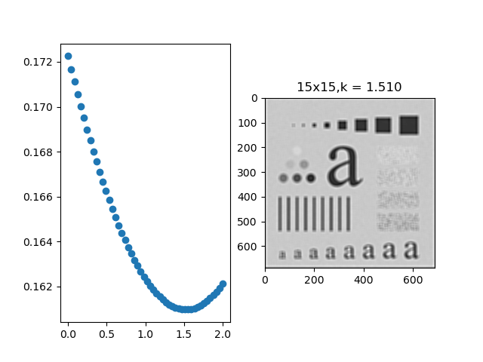

If High-Boost filtering is applied directly to noisy.tif then the noise in the image is also amplified.